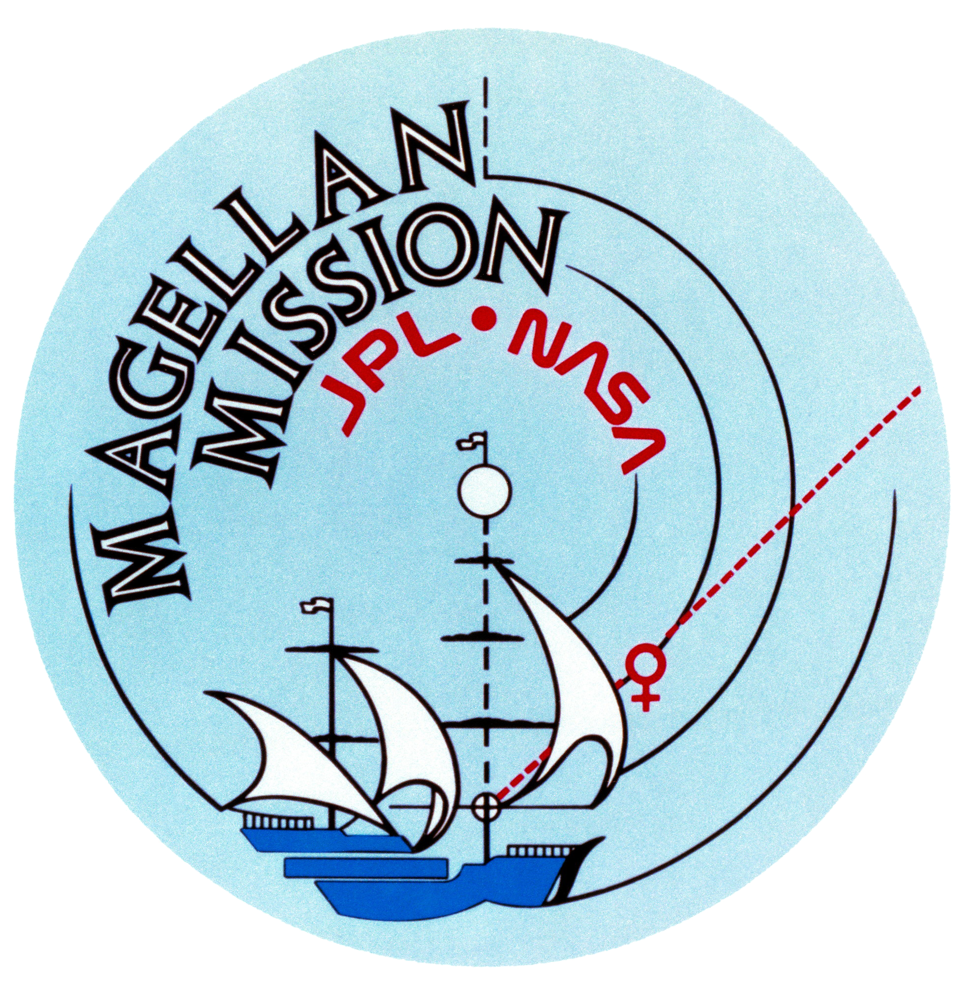

A Summary of the Magellan Mission
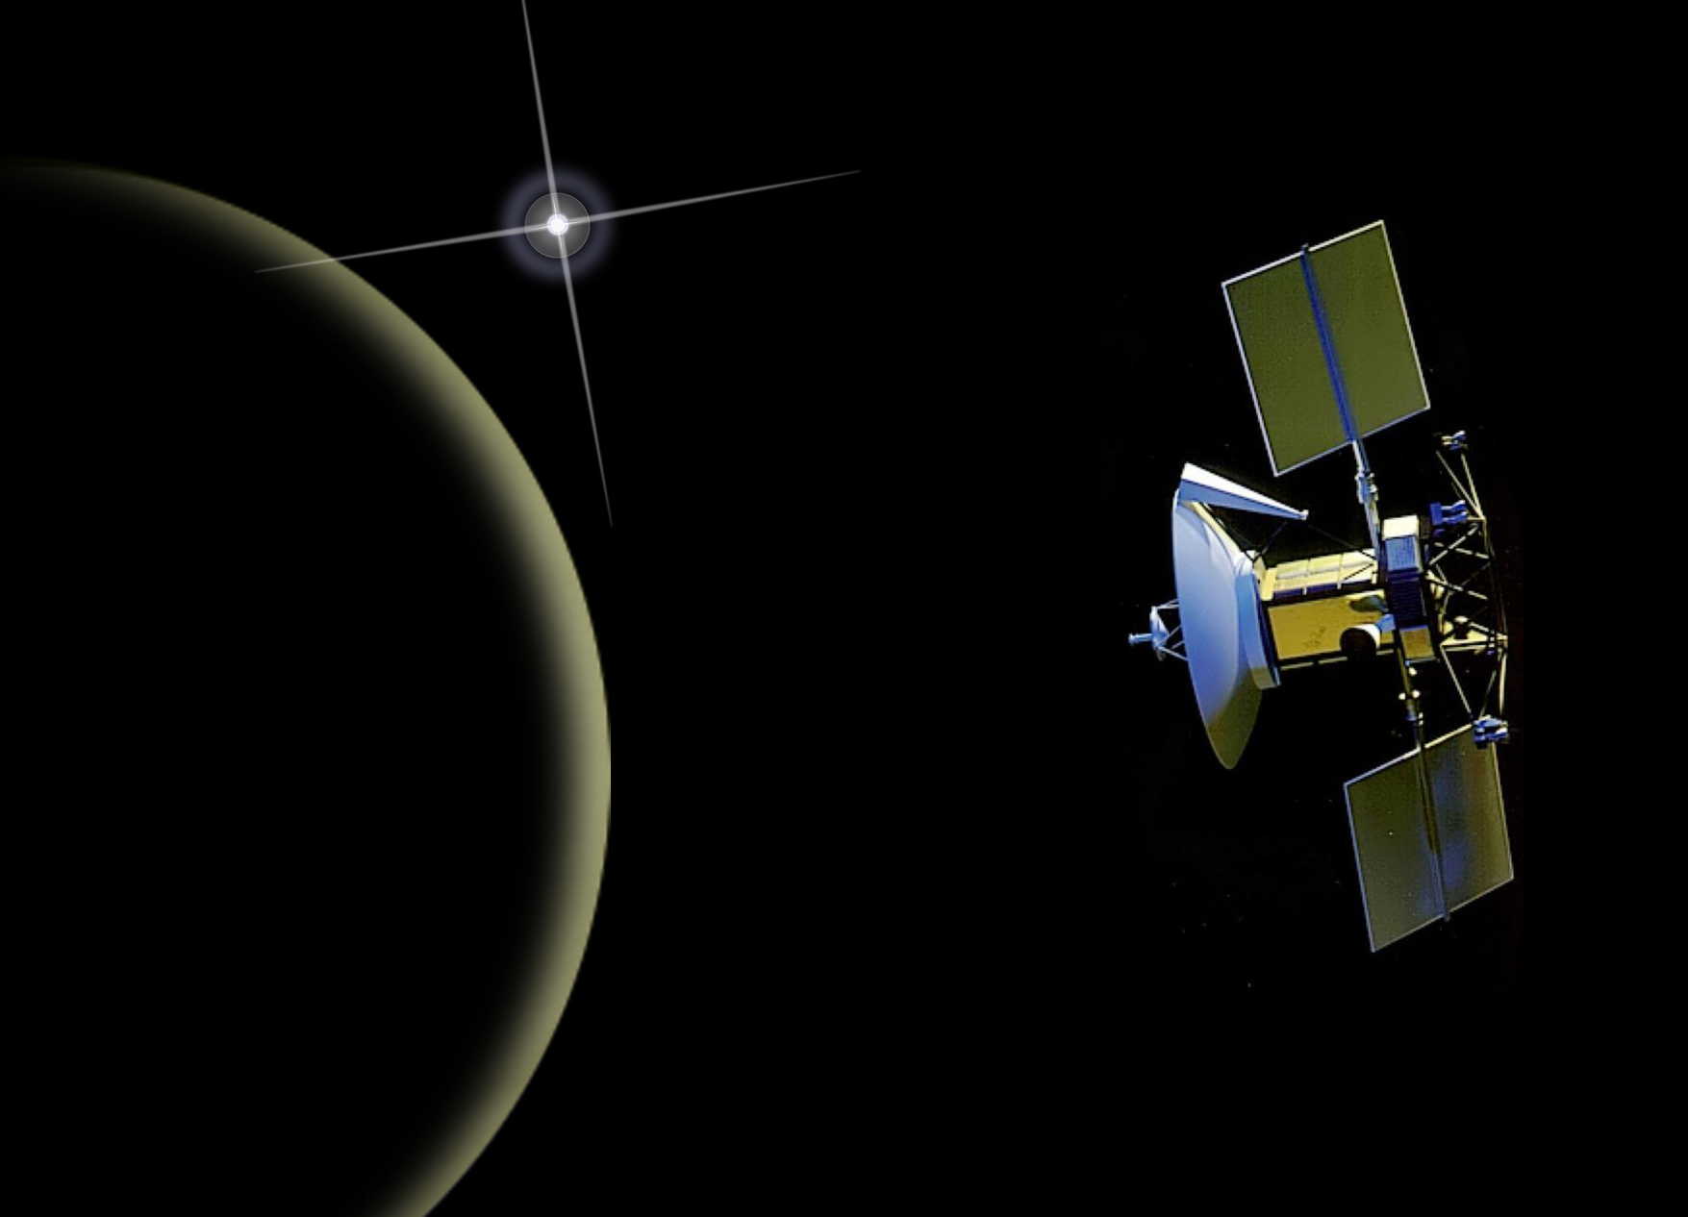

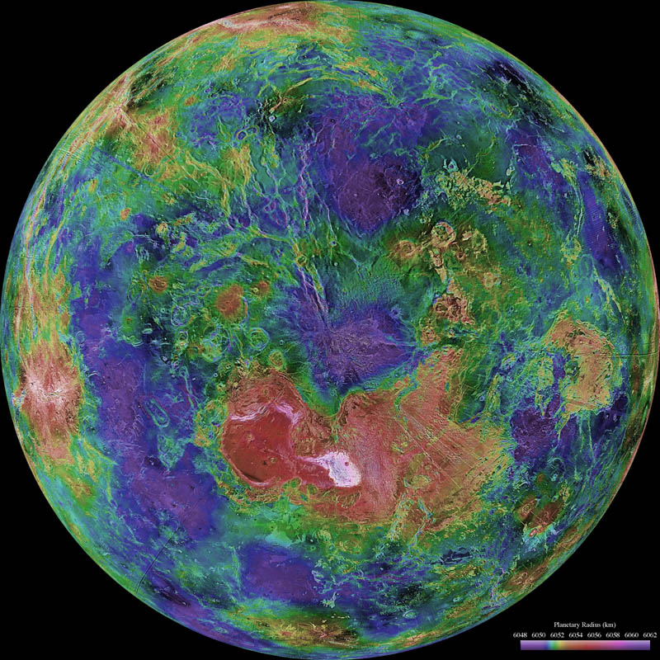

Introduction

Launched May 4, 1989, Magellan, a Venus radar mapper, was the first spacecraft to be launched by the space shuttle. The main instrumentation consisted of a system that functioned in 3 modes: synthetic aperture radar (SAR), altimetry(ALT), and radiometry used to characterize the surface temperature (RAD).

The Magellan spacecraft was inserted into a near-polar elliptical orbit (85.5º inclination) with a periapsis altitude of 294 km at 9.5 deg. N. on August 10, 1990. By Sept 15. 1990 it was returning radar images. By May 15 Magellan had mapped 83.7% of the venusian surface. A second mapping cycle, ending Jan 15, 1002 added coverage up to 96% and a third ending Sept 13 raised the coverage to 98%.

Gravimetric data was collected during the fourth, fifth and sixth cycles that ended May 23, 1993, Aug. 29, 1994, and Oct. 13, 1994 respectively . On Oct 13, 1994 the craft entered the venusian atmosphere. At the end of cycle 4 aerobraking was used to lower and circularize the orbit to obtain higher quality gravimetric data.

Objectives of the mission included:
- Obtain near-global radar images of the Venusian surface with a resolution equivalent to optical imaging of 1.0 km resolution.
- Obtain a near-global topographic map with 50 km spatial and 100 m vertical resolution.
- Obtain near-global gravity field data with 700 km resolution and two to three milligals of accuracy.
- Develop an understanding of the geological structure of the planet, including its density distribution and dynamics.

In addition to the radar data, information concerning the structure of the atmosphere was acquired via radio occultations. The first set of experiments was carried out on Oct 5 & 6, 1991. Others followed in 1992 and 1994.
Publications

R.S. Saunders, et al., Magellan Mission Summary. JGR, VOL. 97, NO. E8, Pages 13,067-13,090, Aug 25, 1992 .

Access to Data

Radio Occultation data is available at the Atmospheric Sciences Node
Link to new Magellan Radio Science Page
Synthetic aperture radar (SAR), altimetry(ALT), and radiometry (RAD) data are available at the Geosciences Node.
http://pds-geosciences.wustl.edu/missions/magellan/index.htm
Synthetic aperture radar (SAR) data is available at the Cartography and Imaging Node
https://pds-imaging.jpl.nasa.gov/volumes/magellan.html

Magellan Radio Occultation Experiment

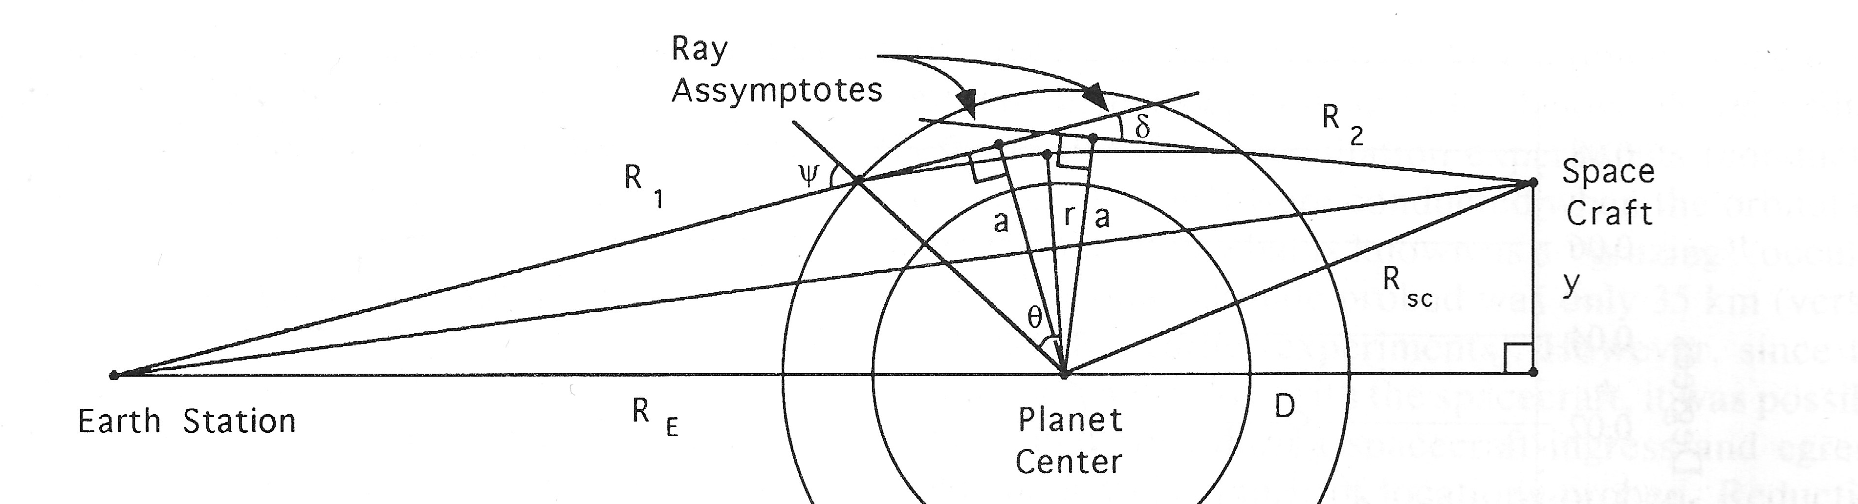
Occultation geometry for one leg of a 2-way Occultation experiment

Introduction

References

Steffes, P.G., J.M. Jenkins, et al., Radio Occultation Studies of the Venus Atmosphere with the Magellan Spacecraft: 1. Experimental Description and Performance,Icarus, 110, 71-78, 1994."

Jenkins, J.M., P.G. Steffes, et al., Radio occultation studies of the Venus atmosphere with the Magellan spacecraft: 2. Results from the October 1991 experiments, Icarus, 110, pp. 79-94, 1994.

Accessing the Raw Data

MGN-V-RSS-1-ROCC-V2.0 is a data set containing The Magellan (MGN) Radio Occultation (ROCC) Raw Data Archive (RDA) and is a time-ordered collection of raw and partially processed data from radio occultation experiments conducted using the Magellan spacecraft while it orbited Venus. The spacecraft radio system was used as the signal source. The spacecraft high-gain antenna (HGA) beamed those signals through the atmosphere of Venus toward Earth, where they were received at stations of the NASA Deep Space Network (DSN). See dataset.cat. The data are located in the following volumes. https://pds-atmospheres.nmsu.edu/PDS/data/mg_2201/catalog/dataset.cat

mg_2201 https://pds-atmospheres.nmsu.edu/cgi-bin/getdir.pl?dir=index&volume=mg_2201
mg_2202 https://pds-atmospheres.nmsu.edu/cgi-bin/getdir.pl?dir=index&volume=mg_2202
mg_2203 https://pds-atmospheres.nmsu.edu/cgi-bin/getdir.pl?dir=index&volume=mg_2203
mg_2204 https://pds-atmospheres.nmsu.edu/cgi-bin/getdir.pl?dir=index&volume=mg_2204
mg_2205 https://pds-atmospheres.nmsu.edu/cgi-bin/getdir.pl?dir=index&volume=mg_2205
mg_2206 https://pds-atmospheres.nmsu.edu/cgi-bin/getdir.pl?dir=index&volume=mg_2206
mg_2207 https://pds-atmospheres.nmsu.edu/cgi-bin/getdir.pl?dir=index&volume=mg_2207
mg_2208 https://pds-atmospheres.nmsu.edu/cgi-bin/getdir.pl?dir=index&volume=mg_2208
mg_2209 https://pds-atmospheres.nmsu.edu/cgi-bin/getdir.pl?dir=index&volume=mg_2209

mg_2210 https://pds-atmospheres.nmsu.edu/cgi-bin/getdir.pl?dir=index&volume=mg_2210
mg_2211 https://pds-atmospheres.nmsu.edu/cgi-bin/getdir.pl?dir=index&volume=mg_2211
mg_2212 https://pds-atmospheres.nmsu.edu/cgi-bin/getdir.pl?dir=index&volume=mg_2212
mg_2213 https://pds-atmospheres.nmsu.edu/cgi-bin/getdir.pl?dir=index&volume=mg_2213
mg_2214 https://pds-atmospheres.nmsu.edu/cgi-bin/getdir.pl?dir=index&volume=mg_2214

Accessing the Derived Data
Two data sets are available that were derived from from dual-frequency ingress radio occultation experiments using the Magellan orbiter on three consecutive orbits (#3212 - #3214) on October 5 and 6, 1991.

RTPD - The MGN-V-RSS-5-OCC-PROF-RTPD-V1.0 data set includes vertical profiles of refractivity, temperature, pressure and density in the neutral Venus atmosphere. (see rtpd under catalog and data) https://pds-atmospheres.nmsu.edu/cgi-bin/getdir.pl?dir=index&volume=mg_2401

ABS -The MGN-V-RSS-5-OCC-PROF-ABS-H2SO4-V1.0 data set includes vertical profiles of 13-cm and 3.6-cm absorptivity and abundance of sulfuric acid vapor (H2SO4). (see abs under catalog and data) https://pds-atmospheres.nmsu.edu/cgi-bin/getdir.pl?dir=index&volume=mg_2401

